Project Management Plan

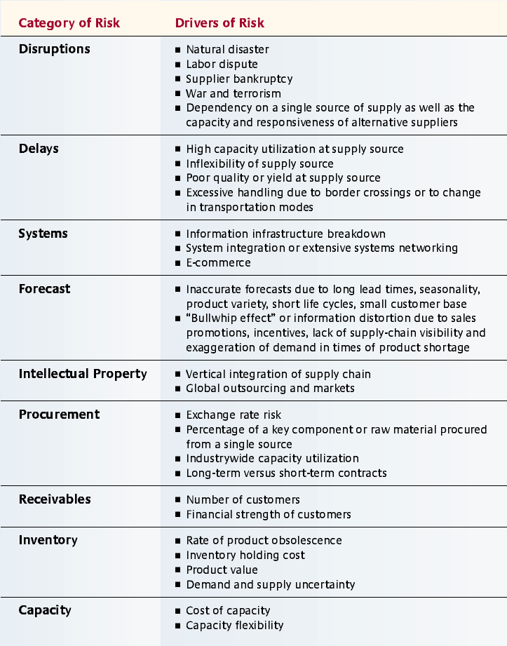

Risk Register

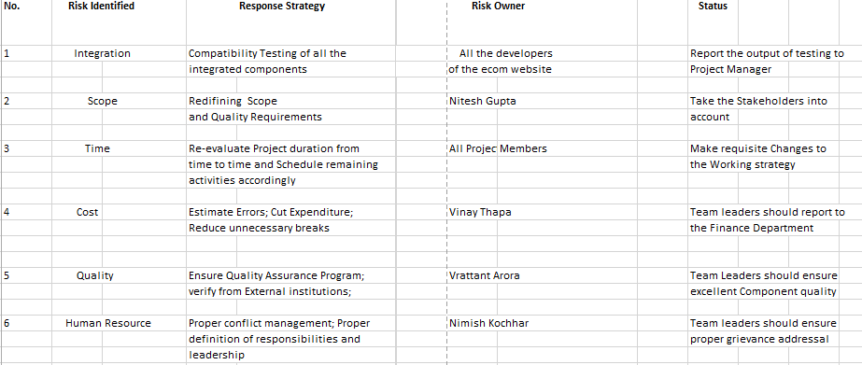

Peer Review Form

|  |  |  |  |  |  |  |  |  |  |
| --- | --- | --- | --- | --- | --- | --- | --- | --- | --- |
|  | |  | | | | | | | |
| **Project :E-Commerce Website** | | | **Date : 2/12/2015** | | | | | | |
| **Peer being Evaluated : Nimish Kochhar, Vinay Thapa ,Nitesh Gupta,Vrattant Arora** | | | | | | | | | |
| **Please rate the following attributes of your peer, on a scale of 1 to 5, where 1 is very poor, 2 is poor, 3 is average, 4 is better than average, and 5 is outstanding. If you feel unable to evaluate a particular attribute, select N/A.** | | | | | | | | | |
| Item | **Description** | |  |  |  |  |  |  | **Comments** |
| 1 | Completes tasks on time | | 5 | 4 | 3 | 2 | 1 | N/A |  |
| 2 | Attends team meetings on time and stays until end | | 5 | 4 | 3 | 2 | 1 | N/A |  |
| 3 | Makes positive contributions | | 5 | 4 | 3 | 2 | 1 | N/A |  |
| 4 | Displays technical competence | | 5 | 4 | 3 | 2 | 1 | N/A |  |
| 5 | Takes responsibility appropriately | | 5 | 4 | 3 | 2 | 1 | N/A |  |
| 6 | Contributes fair share of work | | 5 | 4 | 3 | 2 | 1 | N/A |  |
| 7 | Scope and requirements have been analyzed properly | | 5 | 4 | 3 | 2 | 1 | N/A |  |
| 8 | Proper Schedule and Cost Budgeting | | 5 | 4 | 3 | 2 | 1 | N/A |  |
| 9 | Has the Documentation been done adequately | | 5 | 4 | 3 | 2 | 1 | N/A |  |
| 10 | Different components have been integrated properly | | 5 | 4 | 3 | 2 | 1 | N/A |  |
| 11 | Testing and Debugging process | | 5 | 4 | 3 | 2 | 1 | N/A |  |
| 12 | Demonstrates good problem solving skills | | 5 | 4 | 3 | 2 | 1 | N/A |  |
| 13 | Appropriate Risk Management techniques | | 5 | 4 | 3 | 2 | 1 | N/A |  |
| 14 | Listens well | | 5 | 4 | 3 | 2 | 1 | N/A |  |
| 15 | Coaches less experienced individuals well | | 5 | 4 | 3 | 2 | 1 | N/A |  |
| 16 | User friendly GUI | | 5 | 4 | 3 | 2 | 1 | N/A |  |
| 17 | Have stakeholders been taken into account | | 5 | 4 | 3 | 2 | 1 | N/A |  |
| 18 | Takes the initiative | | 5 | 4 | 3 | 2 | 1 | N/A |  |
| 19 | Reliable | | 5 | 4 | 3 | 2 | 1 | N/A |  |
| 20 | Produces high quality work | | 5 | 4 | 3 | 2 | 1 | N/A |  |
| 21 | Handles conflict well | | 5 | 4 | 3 | 2 | 1 | N/A |  |
| 22 | Accepts feedback well | | 5 | 4 | 3 | 2 | 1 | N/A |  |
| 23 | Well organized | | 5 | 4 | 3 | 2 | 1 | N/A |  |
| 24 | Has a professional demeanor | | 5 | 4 | 3 | 2 | 1 | N/A |  |
| 25 | I look forward to working with this person in the future | | 5 | 4 | 3 | 2 | 1 | N/A |  |

Critical Path Analysis

List of Activities

|  |  |  |
| --- | --- | --- |
| Activity | Immediate Predecessor | Planned Duration (Days) |
| Team Formation | – | 7 |
| Brainstorm Ideas | Team Formation | 5 |
| Team Name & Blog | Team Formation | 3 |
| Activities list | Brainstorm Ideas,  Team Name & Blog | 5 |
| Gantt Chart | Activities list | 5 |
| Network Diagram | Activities list | 7 |
| Website Content | Activities list | 6 |
| Technology Decision | Gantt Chart,  Network Diagram | 7 |
| Software Decision | Gantt Chart,  Network Diagram | 6 |
| User Interface | Technology Decision,  Software Decision | 24 |
| Database | Technology Decision,  Software Decision | 10 |
| Testing | User Interface,  Database | 15 |
| Wrap-Up | Testing | 10 |
| Documentation & Presentation | Wrap-Up | 2 |

Total Planned Duration: 82 days

Network Diagram

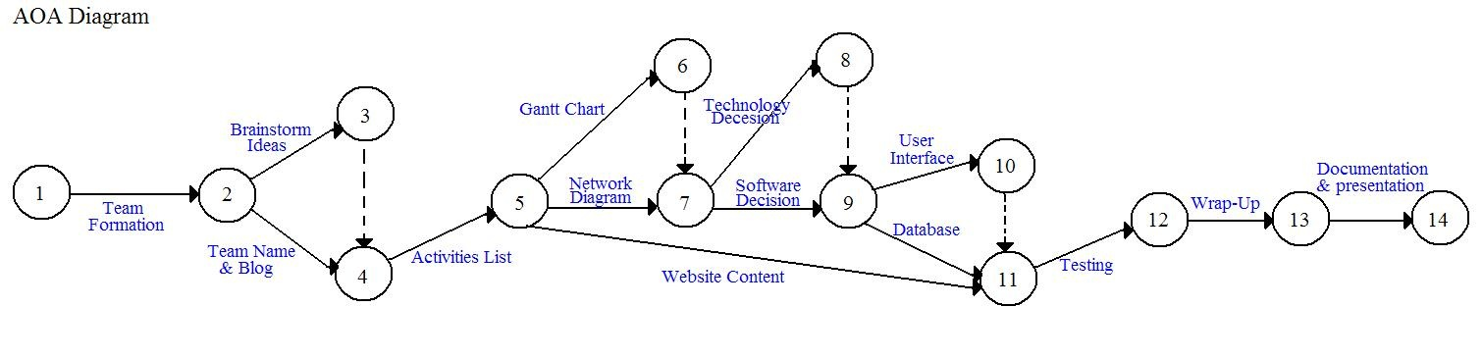

Critical path: 1-2-3-4-5-7-8-9-10-11-12-13-14

PERT Analysis

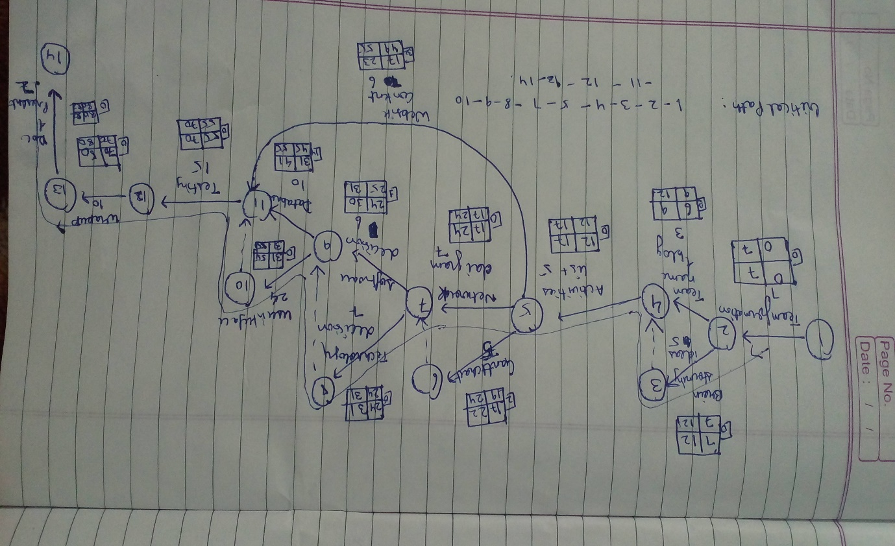

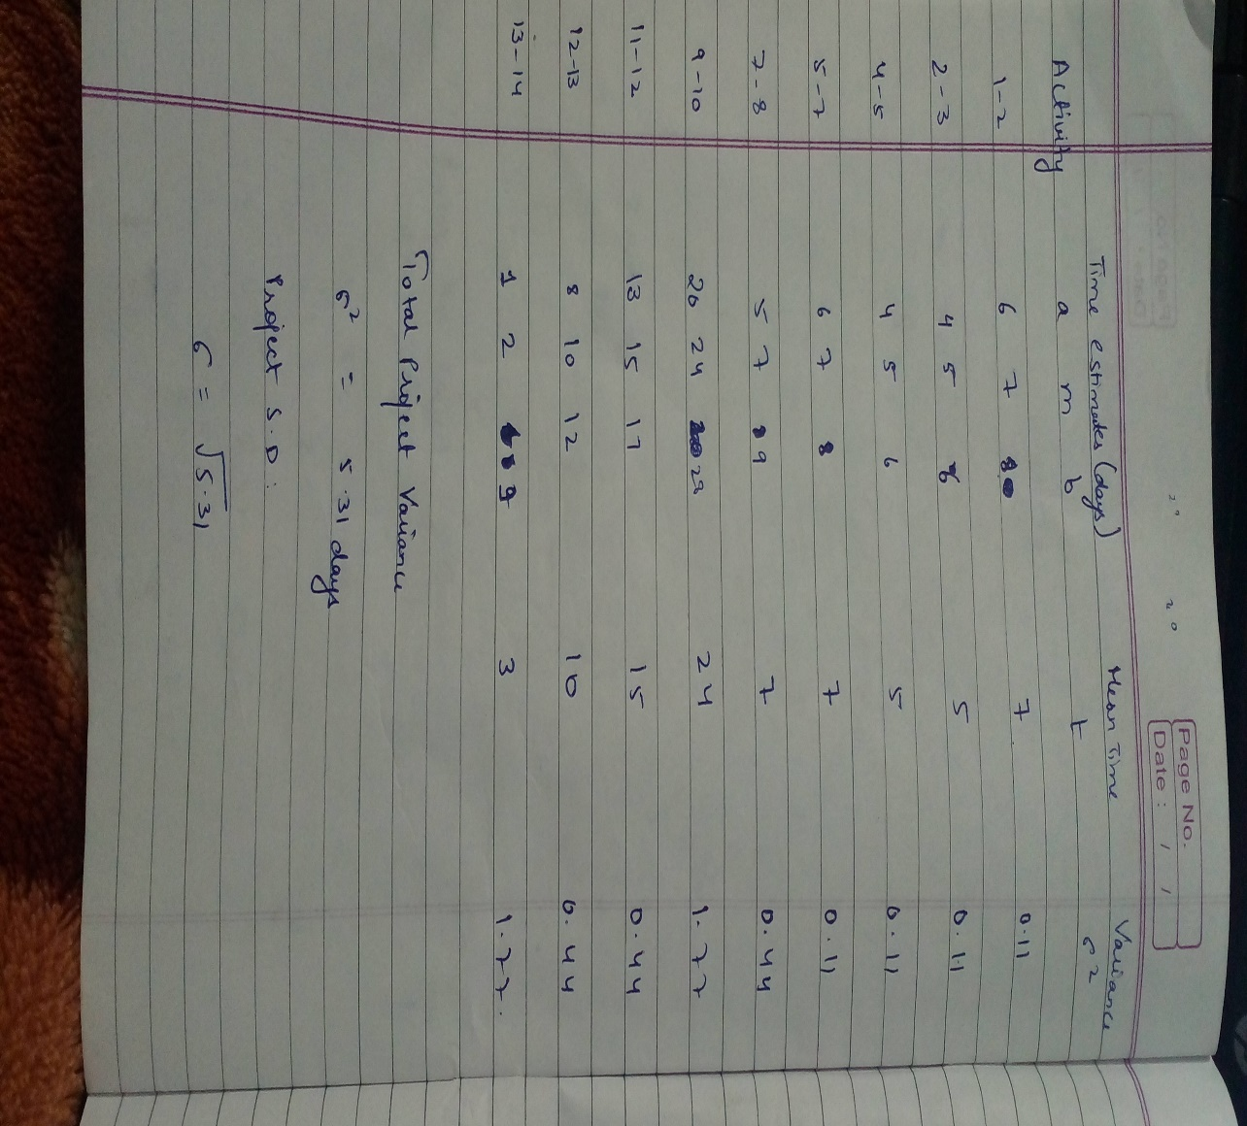

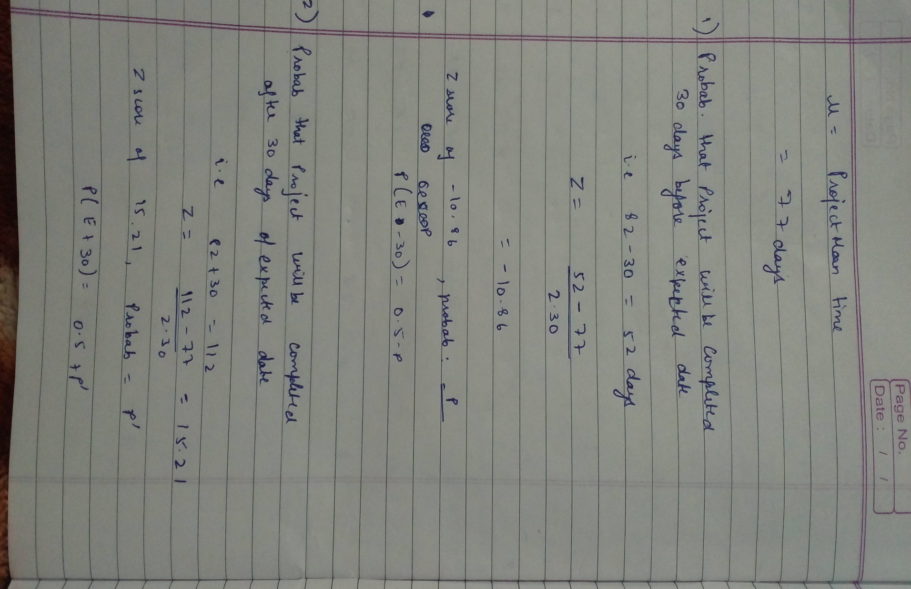

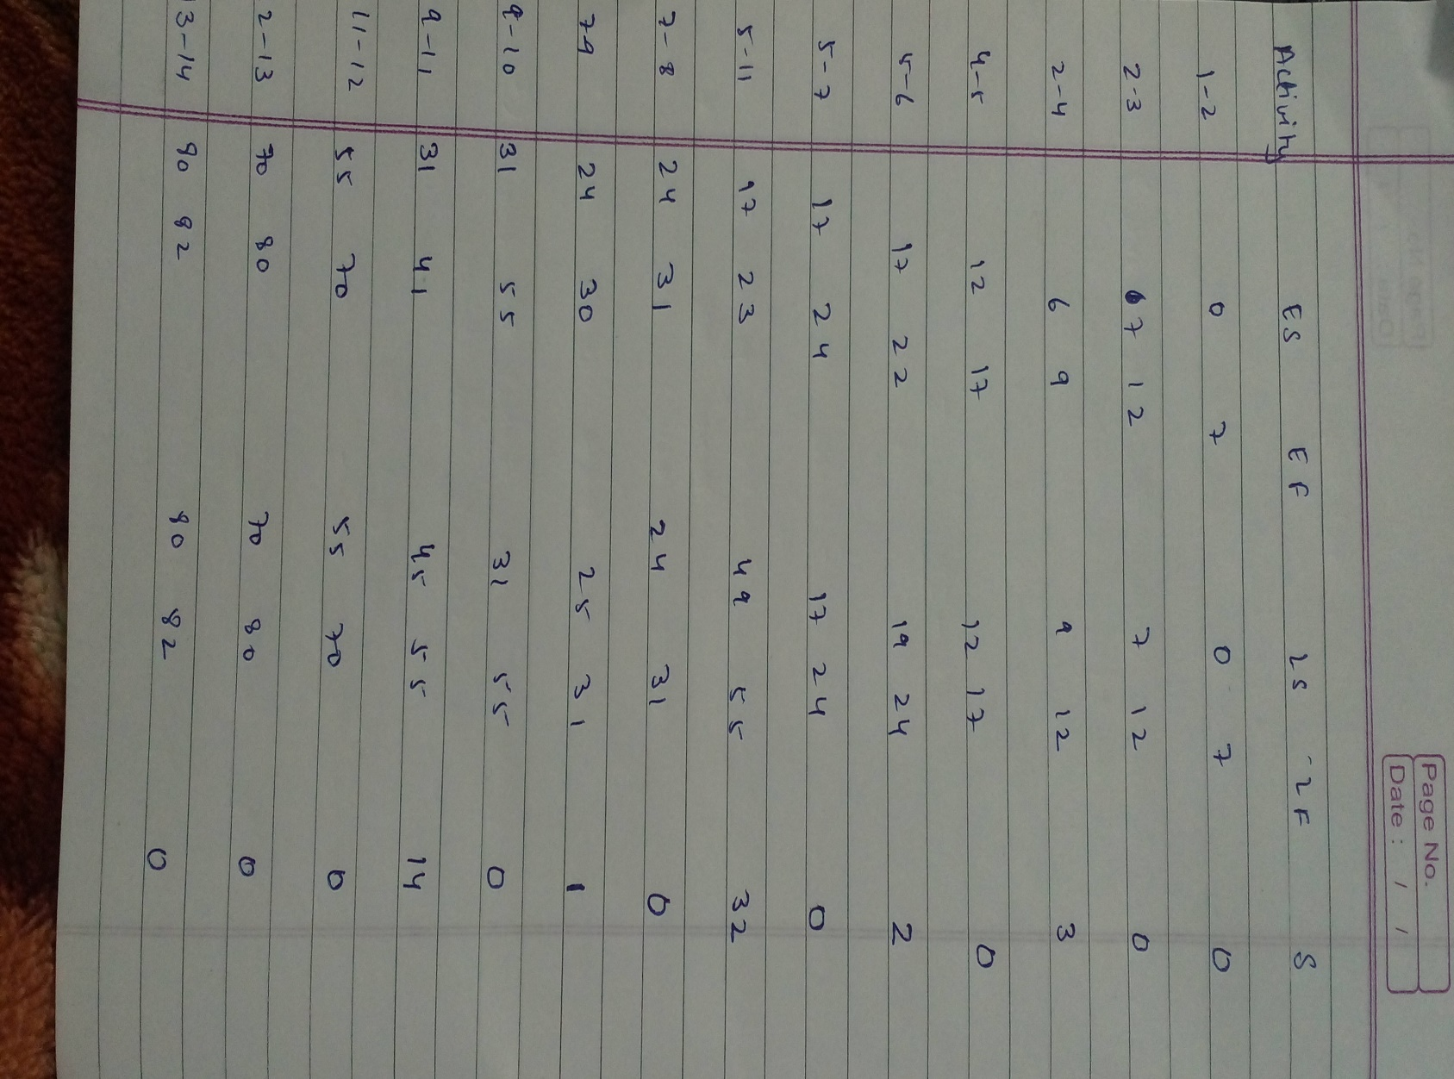

**Component Based Development**

***Project File***

**Submitted by:**

**Nitesh Gupta(101412026)**

**Nimish Kochhar(101462005)**

**Vinay Thapa(1014102044)**

**Vrattant Arora(101412046)**

**Software Project Management**

***Project File***

**Submitted by:**

**Nitesh Gupta(101412026)**

**Nimish Kochhar(101462005)**

**Vinay Thapa(1014102044)**

**Vrattant Arora(101412046)**